CI (Git and Jenkins)

Putty Action: Free Style Project and MultiBranch pipeline

Install JAVA,Git and Jenkins.

1 sudo yum -y install unzip java-1.8.0-openjdk
2 sudo yum update -y
3 sudo yum -y install unzip java-1.8.0-openjdk
4 java -version
5 / gradlew init
6 sudo yum -y install epel-release
7 sudo yum install -y wget
8 sudo wget -O /etc/yum.repos.d/jenkins.repo http://pkg.jenkins-ci.org/redhat-stable/jenkins.repo
9 sudo rpm --import https://jenkins-ci.org/redhat/jenkins-ci.org.key
10 sudo yum -y install jenkins-2.121.1
11 sudo systemctl enable jenkins
12 sudo systemctl start jenkins
13 sudo cat /var/lib/jenkins/secrets/initialAdminPassword
14 sudo yum install -y git
15 history

Go to Git->Developer Settings->Personal Access token-Generate New Token

e9c02ac080c14b4bb3a08f6a53b014fd5e7a25de
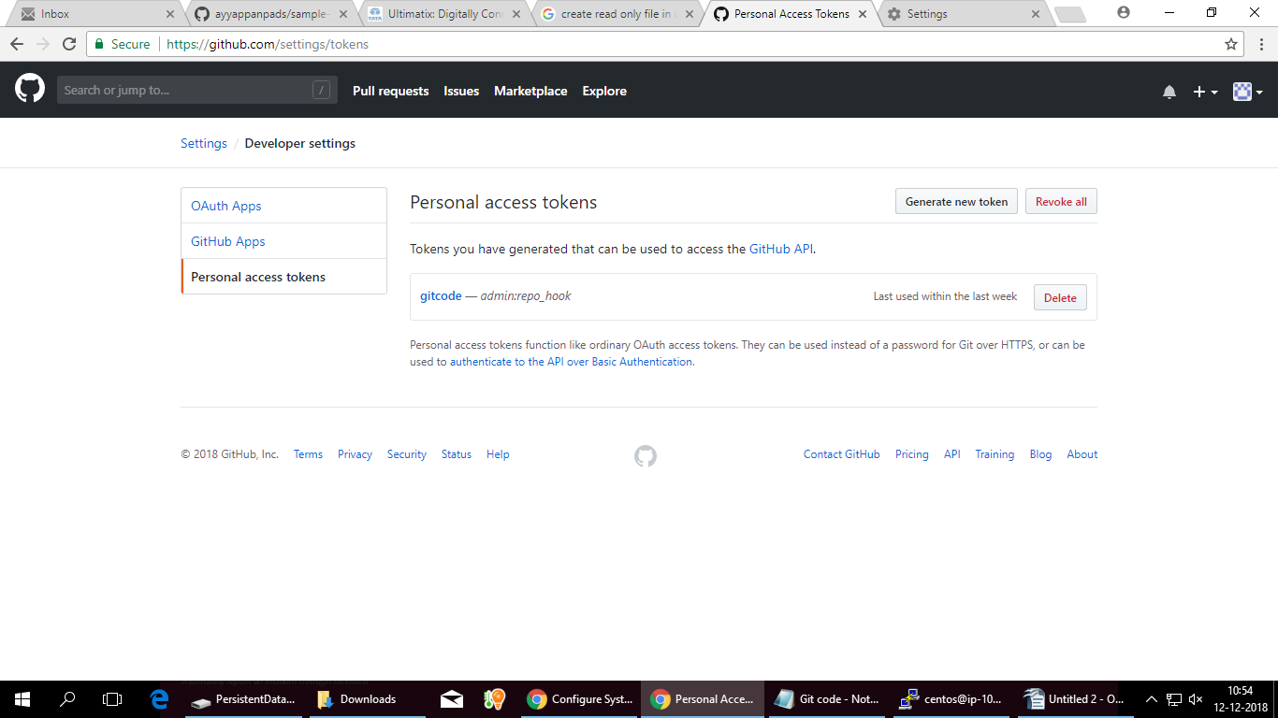
Go to Jenkins -Manage Jenkins-Goto GitHub

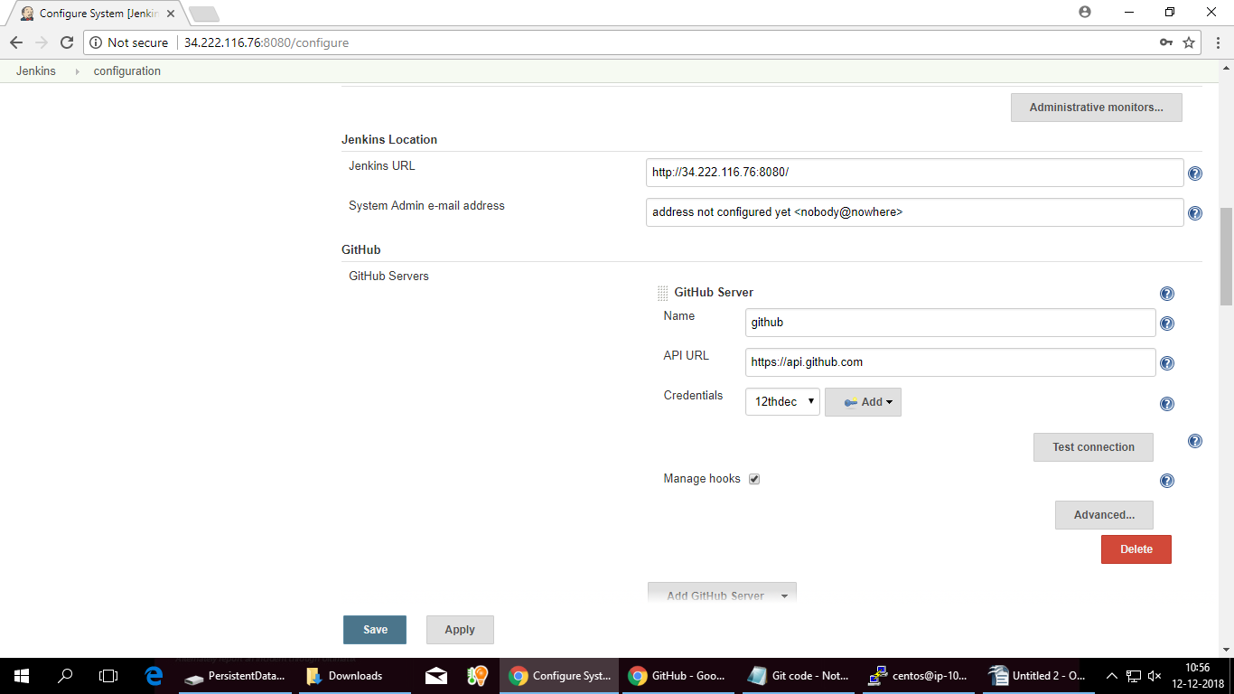
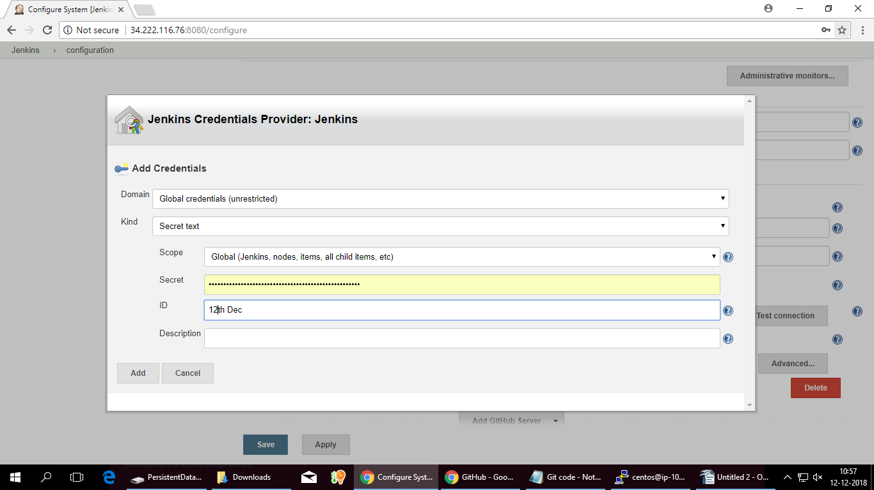

Click test connection button
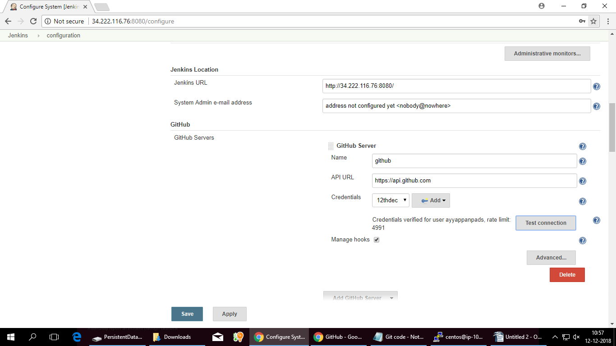
Clikc Apply and Save button.

Go to Jenkins-Click create new job
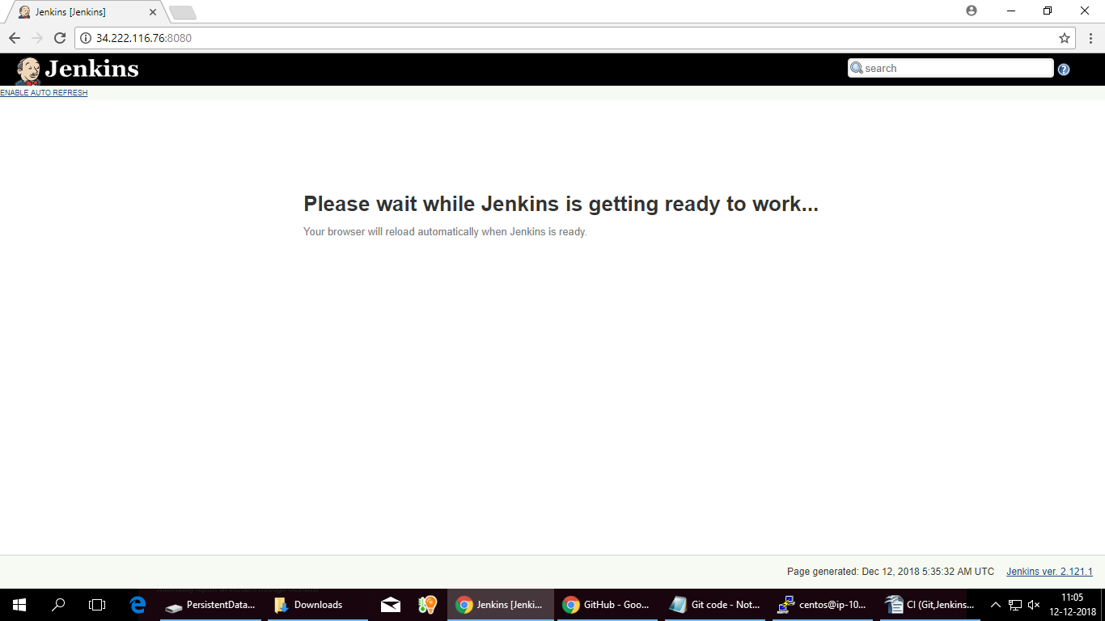

SecondDayCI-CD

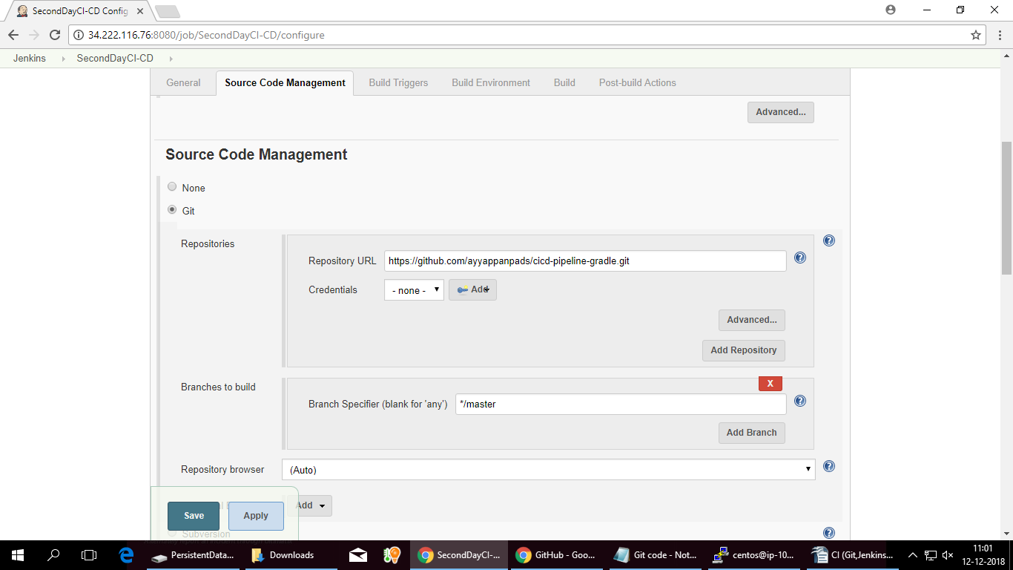

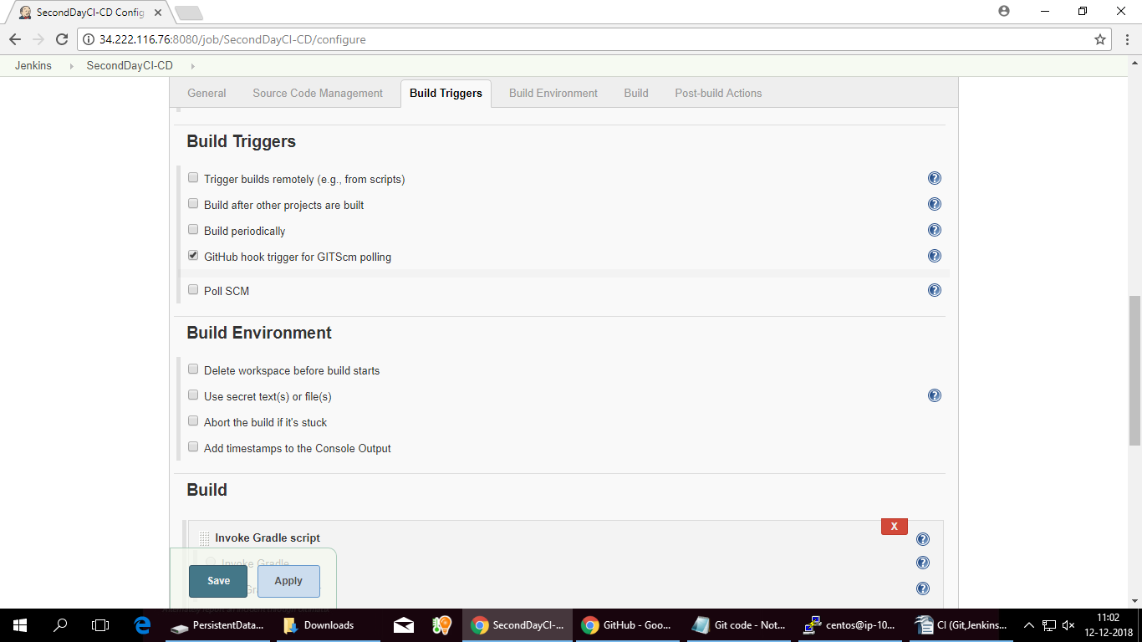
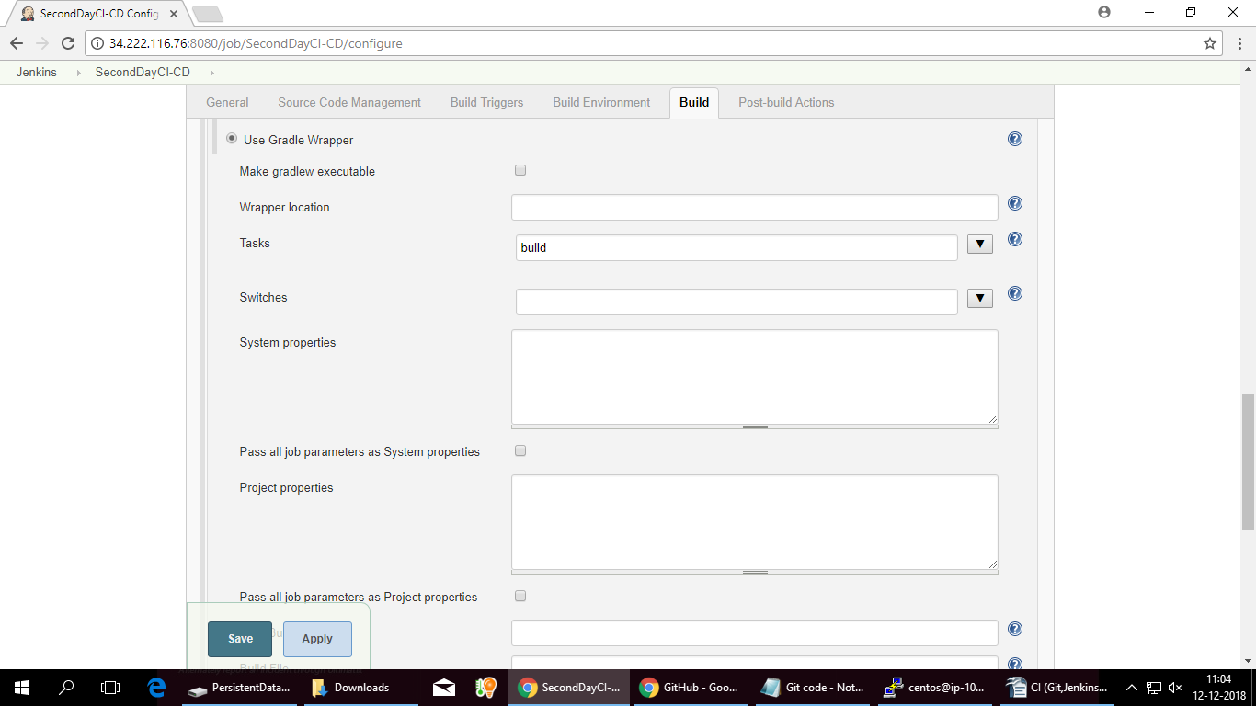
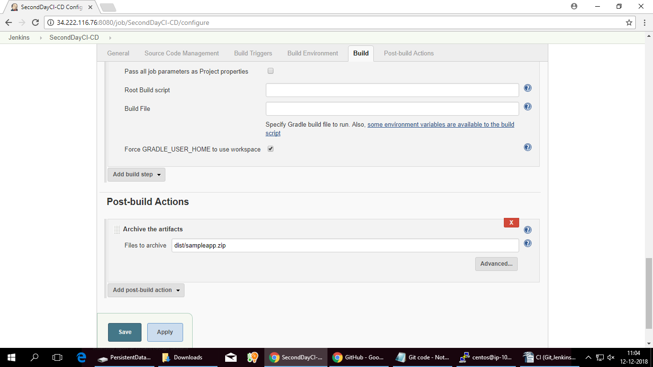
Just Apply and Save .

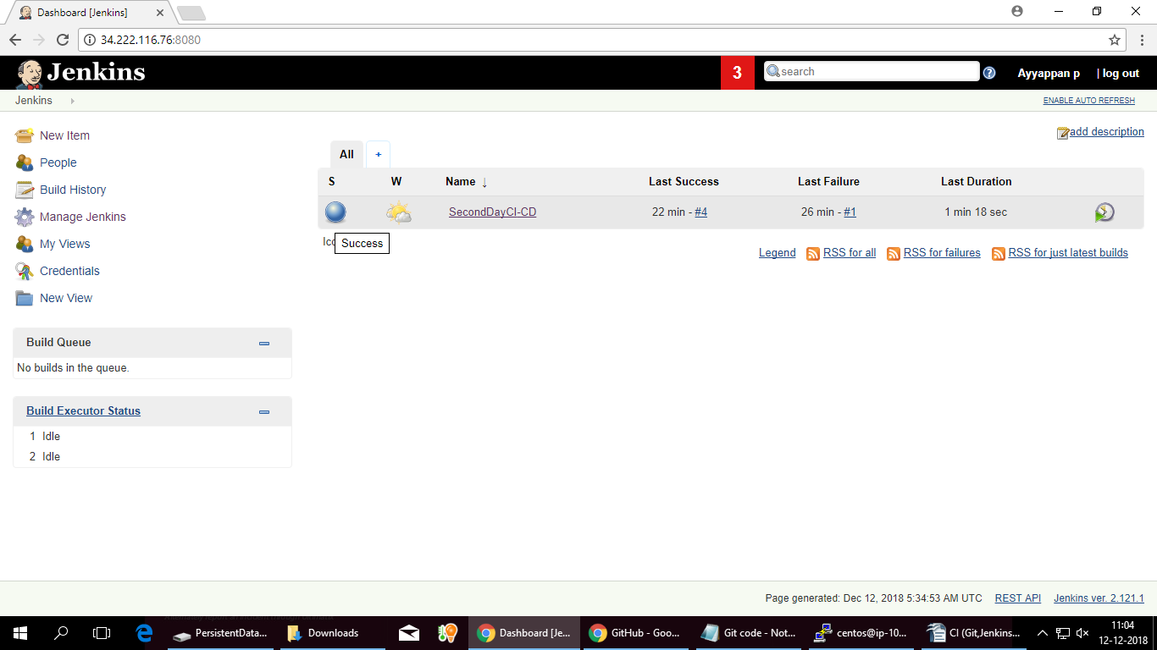

MultiBranch Pipeline:
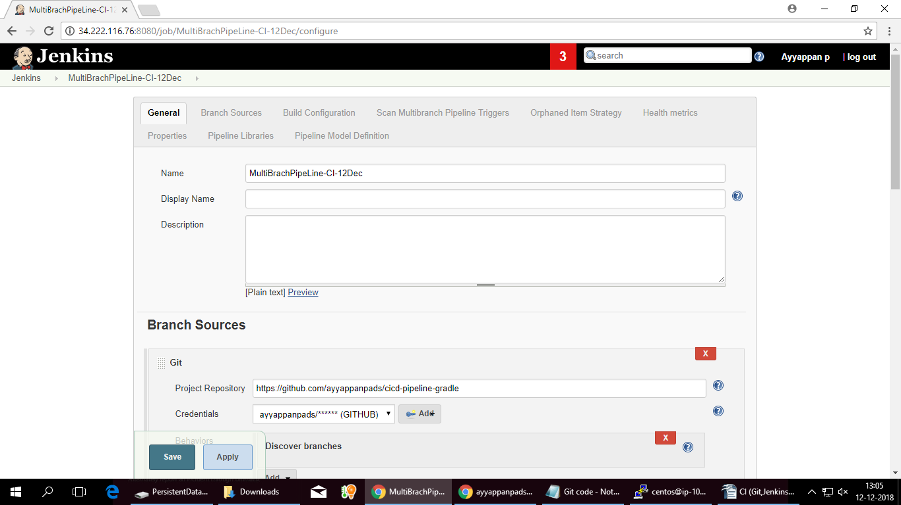
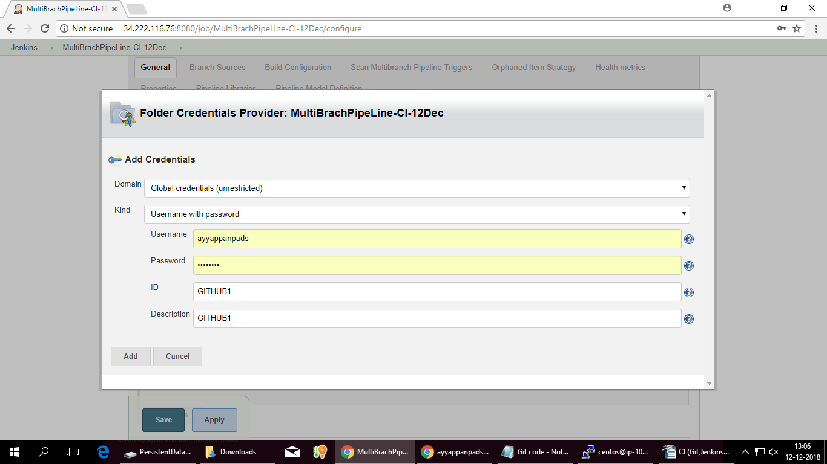

PIPELINE: will do below setup for Maven project

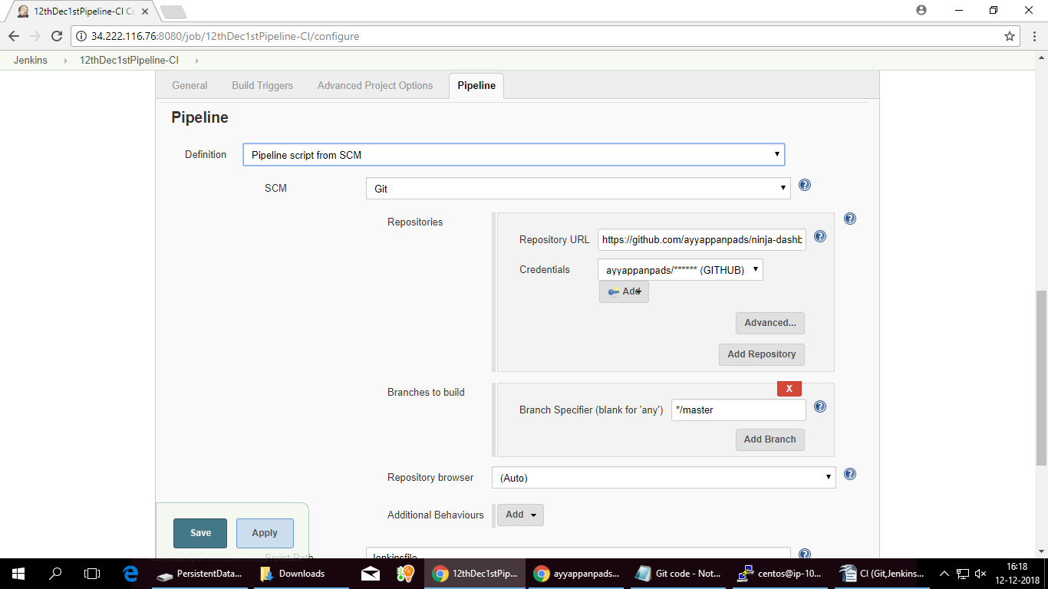

Pipeline as code Gradle:
pipeline {
agent any
stages {
stage ('Checkout'){
steps {
checkout scm
}}
stage ('Build'){
steps {
echo 'Running Build Automation'
sh './gradlew build --no-daemon'
archiveArtifacts artifacts: 'dist/sampleapp.zip'
}
}
}
}

Maven pipeline code
pipeline {
agent any
stages {
stage('CodeCheckout') {
steps {
script {
checkout scm
def mvnHome = tool 'maven-3'
def javaHome = tool 'JAVA_1.8'
}
}
}
stage('build customer app code') {
steps {
script {
def mvnHome = tool 'maven-3'
def javaHome = tool 'JAVA_1.8'
sh 'mvn clean install'
}
}
}
}
}

Go to Jenkins-New Item as 'Pipeline 12thDec1stPipeline-CI'
project->Pipeline
Manage Jenkins
Before that remove (uninstall) Maven and JAVA.

Following process is for CentOS to made JENKINS_USER as root
1. Open up the this script (using VIM or other editor):

vim /etc/sysconfig/jenkins
2. Find this $JENKINS_USER and change to “root”:

$JENKINS_USER="root"
3. Then change the ownership of Jenkins home, webroot and logs:

chown -R root:root /var/lib/jenkins
chown -R root:root /var/cache/jenkins
chown -R root:root /var/log/jenkins

4) Restart Jenkins and check the user has been changed:
33 sudo systemctl restart jenkins
34 sudo systemctl start jenkins

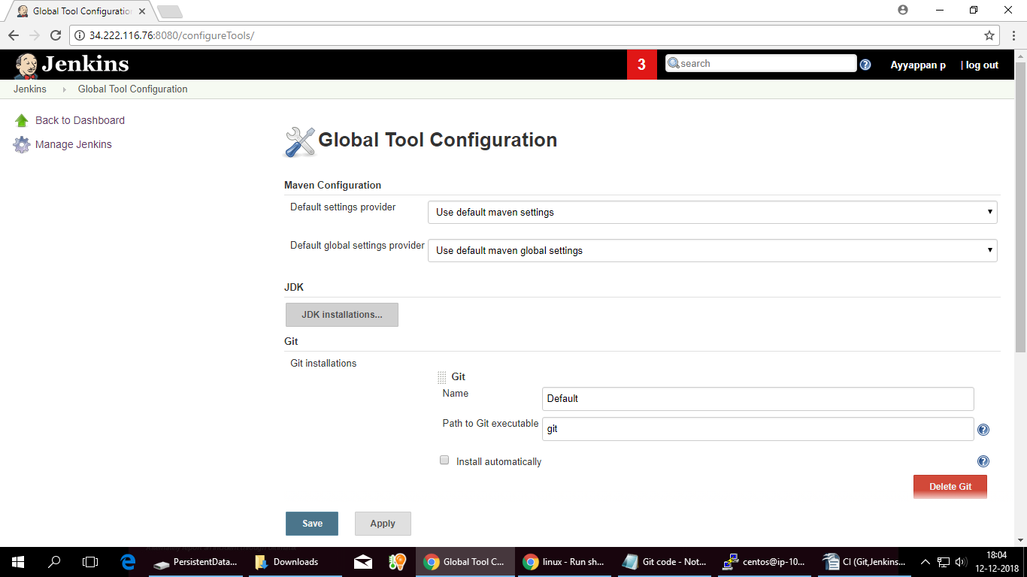
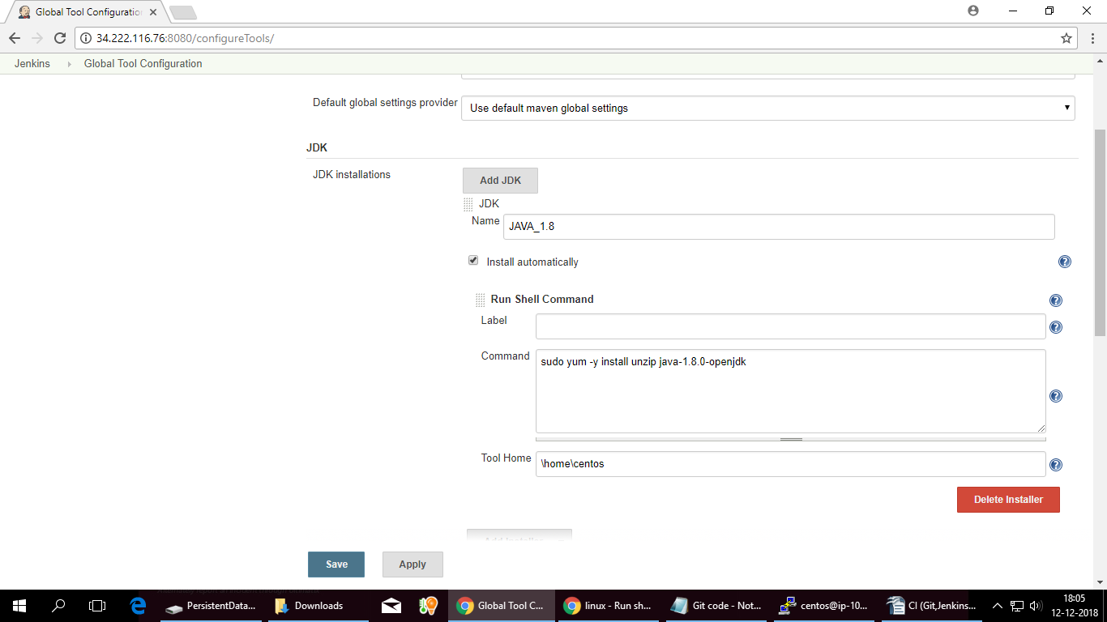

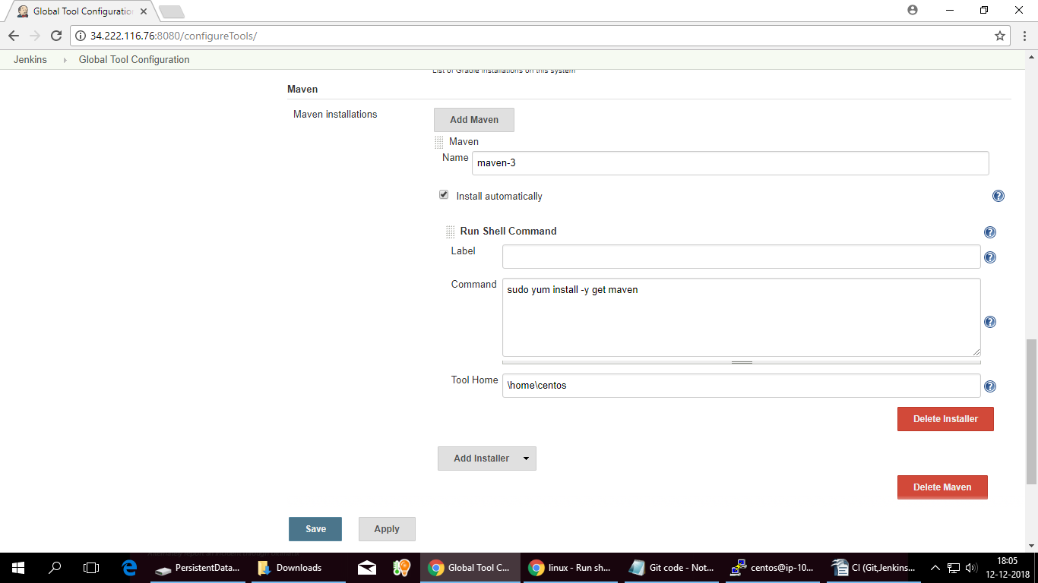

DOCKERS and CONTAINERS: 13-Dec-2019 -Anwesha/Devjit

Create Dockerfile in Git

FROM node:carbon
WORKDIR /usr/src/app
COPY package*.json ./
RUN npm install
COPY ..
EXPOSE 3030
CMD ["npm","start"]

Dockers-Dockers Engine

single vm-setup docker engine-keep multiple container

Single VM-Single Docker image-same multiple container

sudo yum remove docker
sudo yum install docker
sudo systemctl start docker
sudo systemctl status docker
sudo systemctl enable docker
sudo systemctl status docker

Docker should be enabled

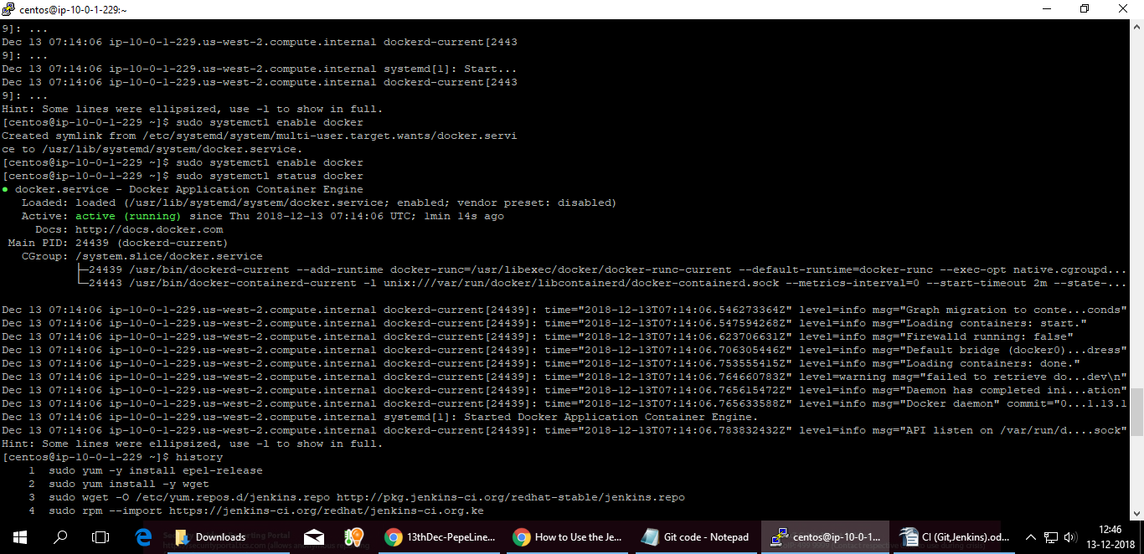

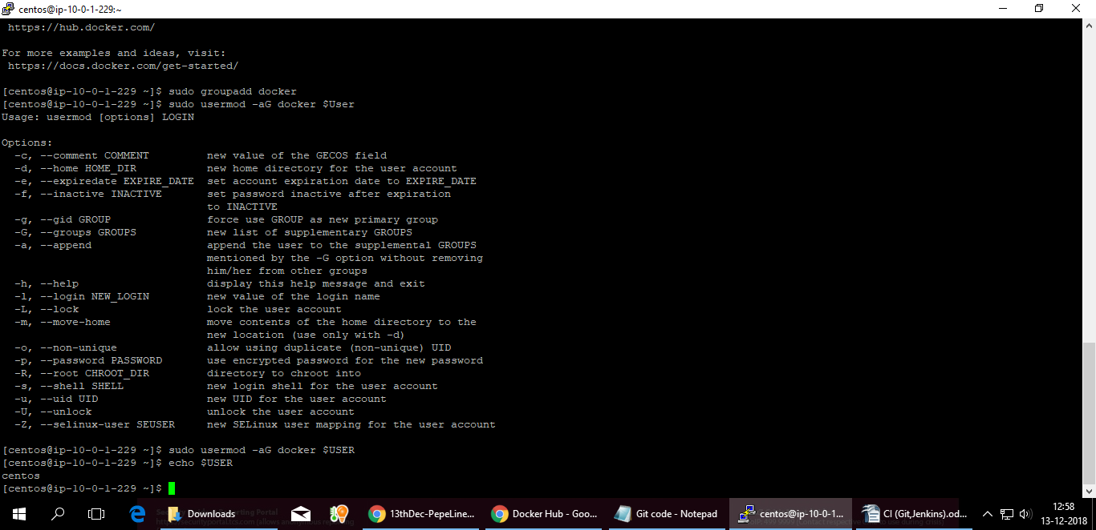

sudo groupadd docker
sudo usermod -aG docker $USER
echo $USER

docker run hello-world
docker images
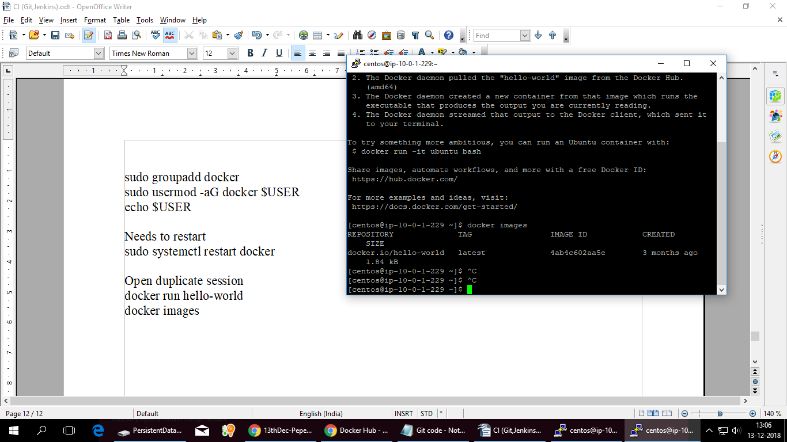
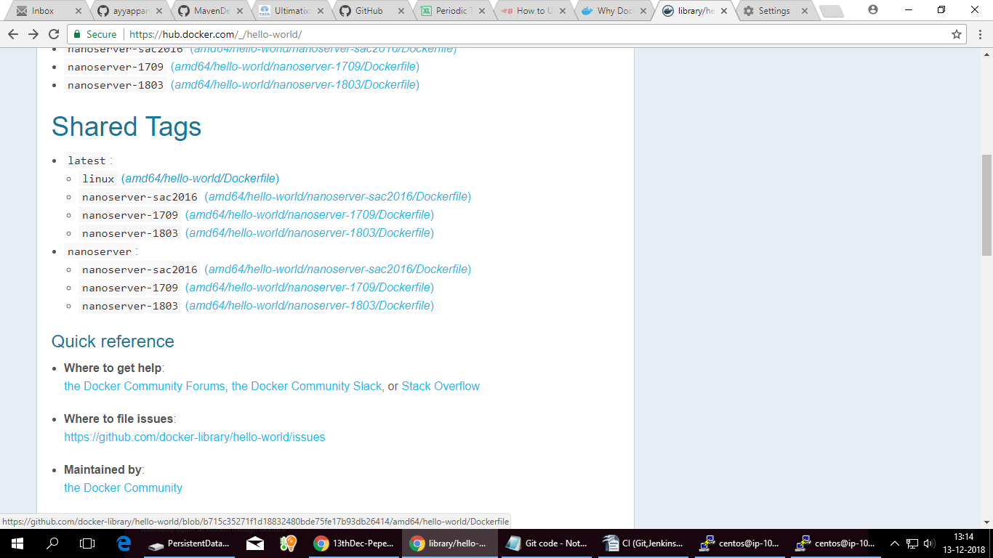
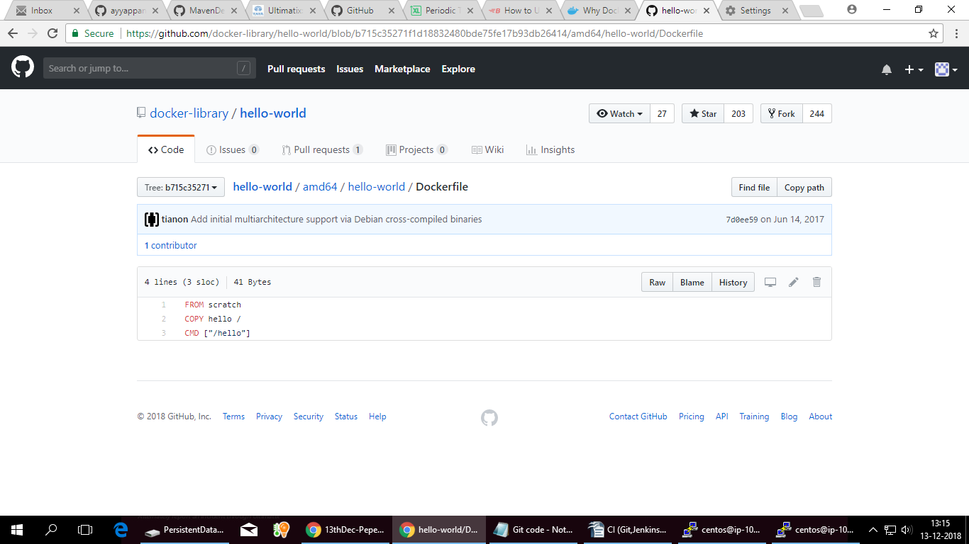
shared dogs-Linux

To create image

sudo docker build -t ayyappanpads/sampleapp .
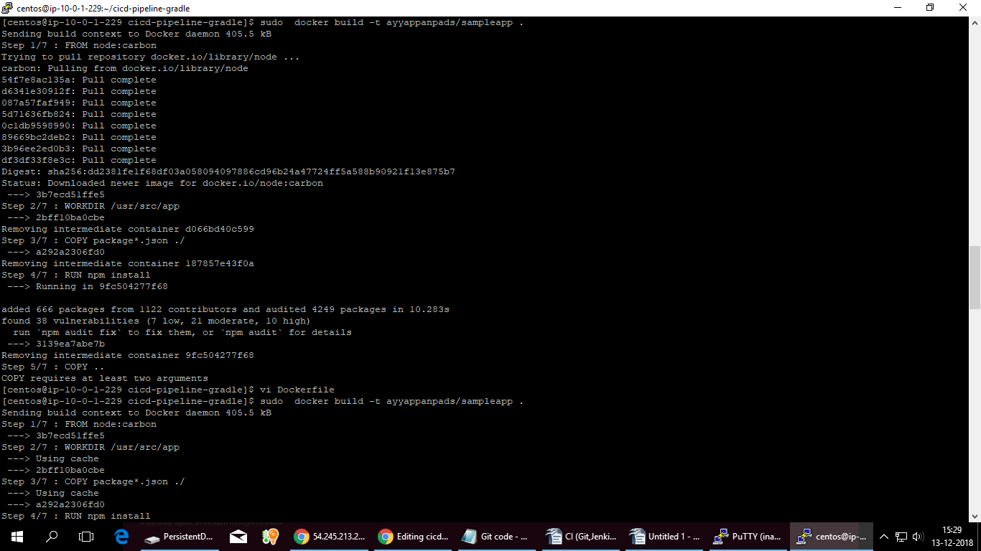
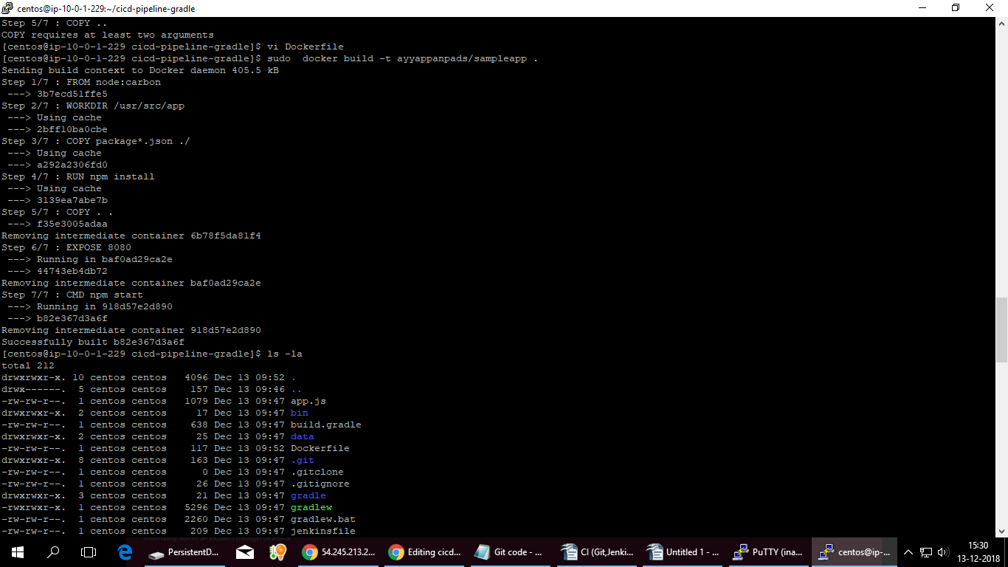

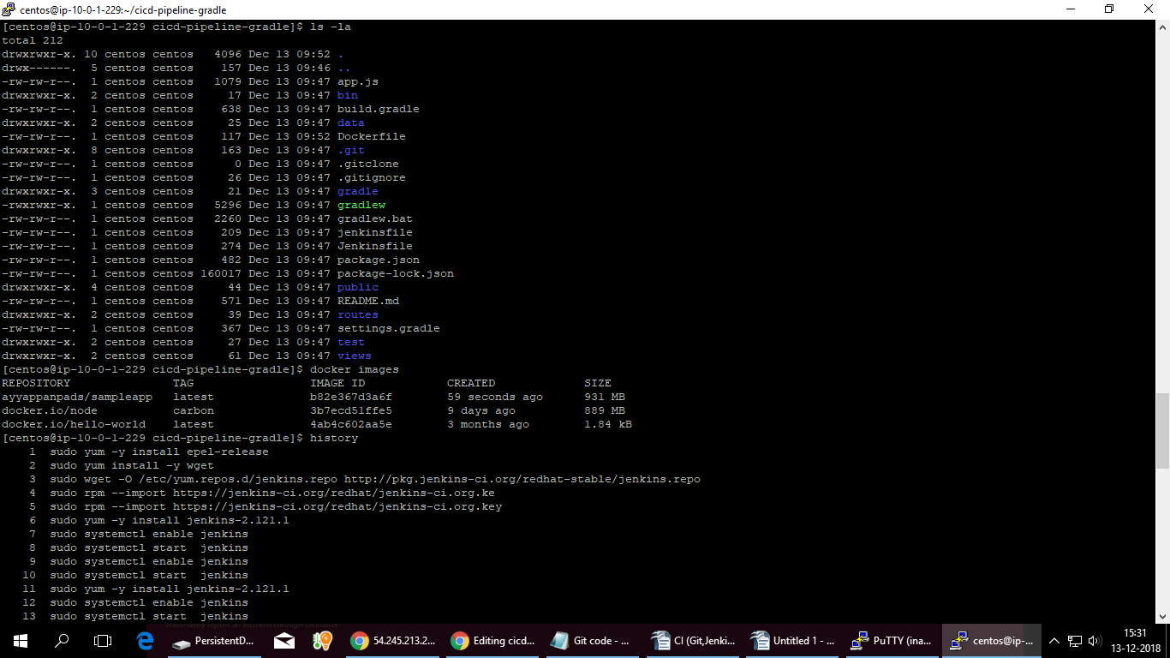
docker images -will display all the images.
List all folder: ls -la

Run Dockers :sudo docker run -p 8081:3030 -d ayyappanpads/sampleapp

Running Status :docker ps -a

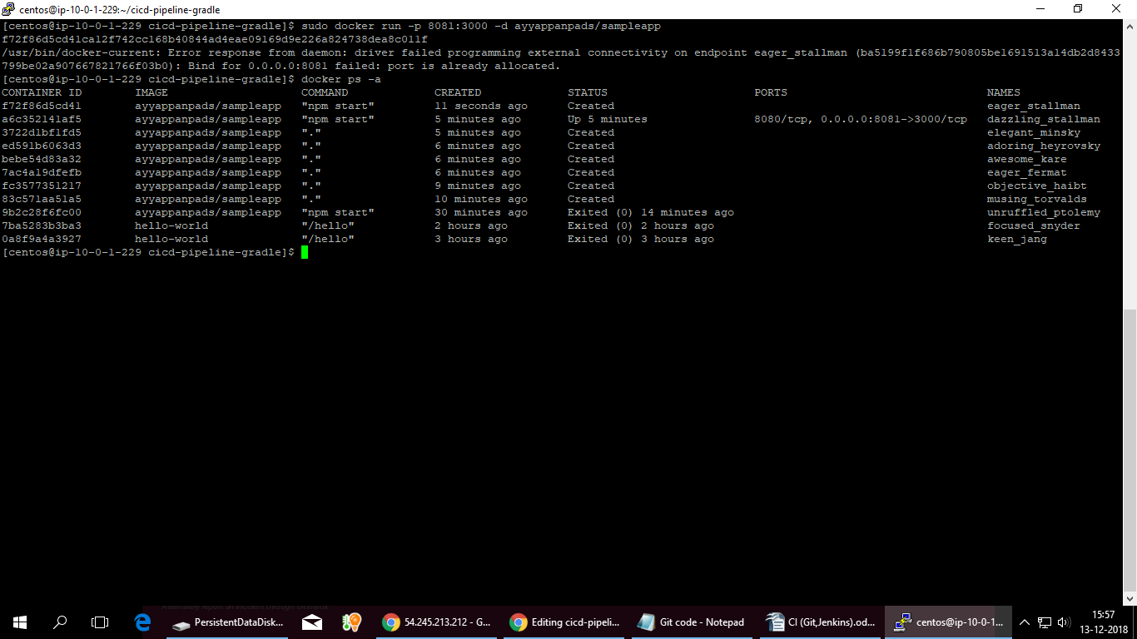

docker exec -it af980d09d7cd bash
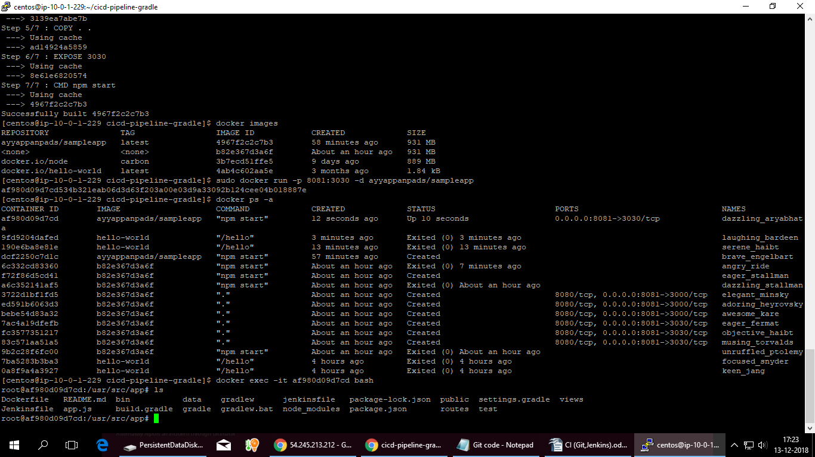
docker ps -see the currnt running
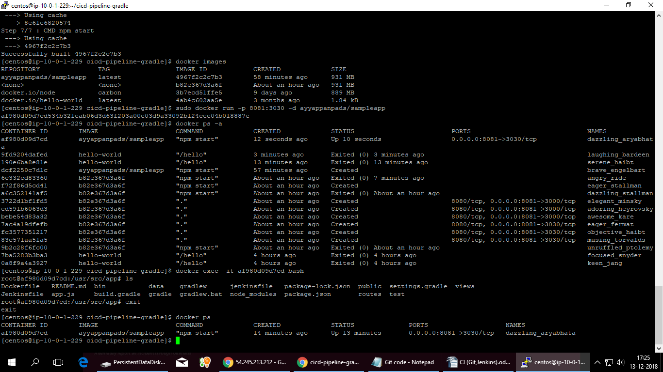
second time;
vi Dockerfile
Change the port name from 3030 to 3000
sudo docker build -t ayyappanpads/sampleapp .
sudo docker run -p 8081:3000 -d ayyappanpads/sampleapp
docker ps

To ensure that docker image -Apps is Running

